Loop gain

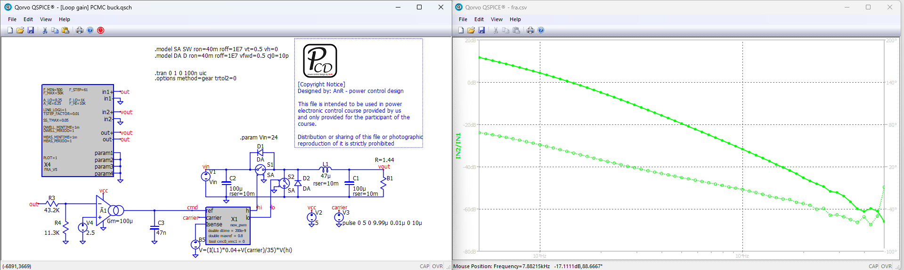

Audio susceptibility

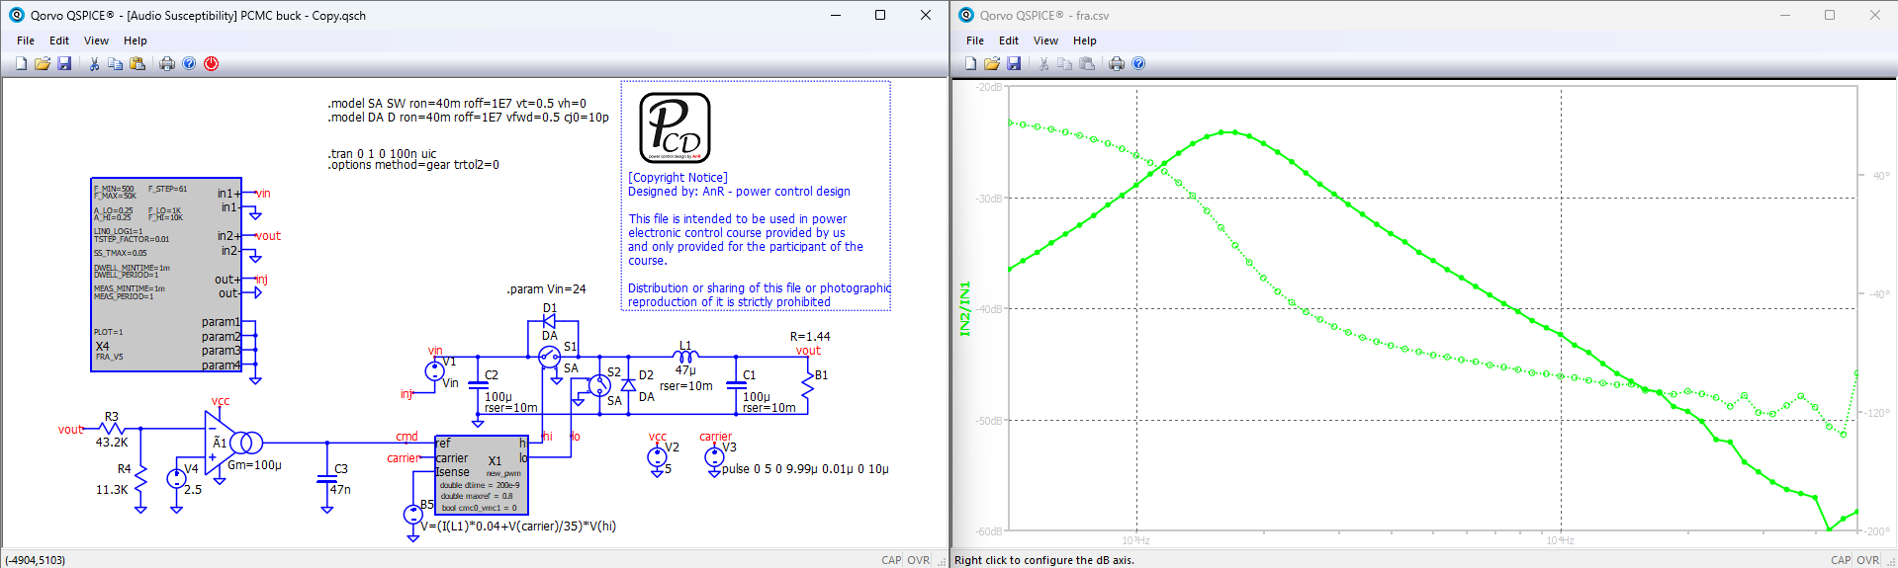

Input impedance

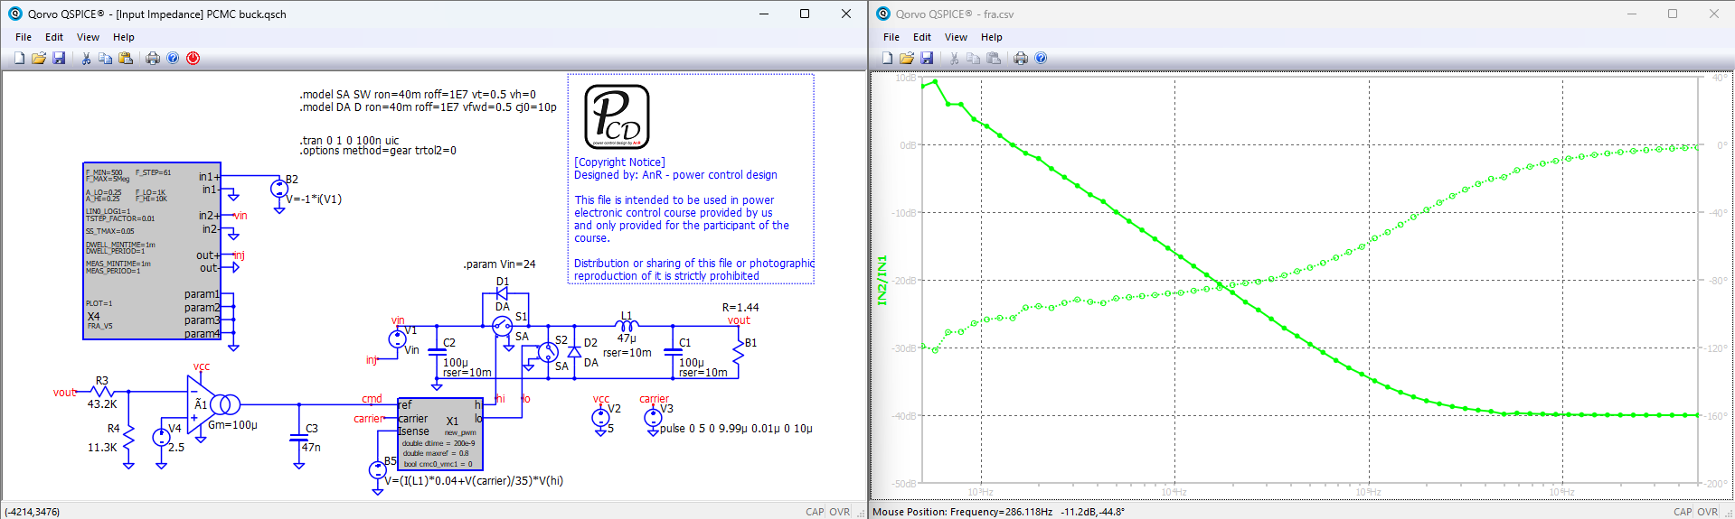

Output impedance

